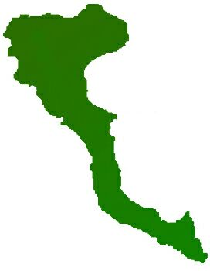

|  |  |
| --- | --- |
| **Team: 3-D Protocol number: 2** | |
|  | |
| **Author:** Arenas Pérez, Pedro José | **Date**: 9.11.2020 |
| **Place:** MS Teams at 19.20 hrs. |
| **Participants:**  - Arenas, Pedro | |

| **Protocol of the meeting of 3 November 2020** | | |
| --- | --- | --- |
| **Topic** | **Results** | **Time** |
| Update protocol template | Added columns for place of the meeting and time spent in topics. | 5 min |
| Prepare pitch idea presentation for 10.11.2020 | Slides are uploaded at Moodle and also Gitlab. Presentation video is uploaded at <https://youtu.be/_a19yOrPegY> | 2 hrs |